**Html basics**

**Table of content**

* What are the basic HTML codes?
* What is the basic concept of HTML?

**what is html document**

1. How do you create an HTML document?
2. What is html heading
3. How to use heading in html

**What is html paragraph?**

1. What is the HTML tag for a paragraph?
2. What is horizontal rule in HTML?
3. What is horizontal rule tag in HTML?

**What is an html image? With example**

**Q 1) What are the basic HTML codes?**

The term HTML code defines the standard content or information which is to be written into the Text editor. Every code written by some standard set of rules which are predefine under the standard libraries. HTML Code is nothing but the secret or encoded contend written under the text editor which is to be displayed on your web browser as an output. HTML code consist of different tags some tags are basic and some are used for formatting.

**<!DOCTYPE html>** - This tag is use for declaration purpose. It Helps the web browser to identify the given web page is written in the mark-up language.

**<html>** - This is a root of HTML. All the content that will starts within html and html tags will be displayed on the web page. html code starts with the <html > and end with </html>.

**For Example**-<html > </html>.

**<head>** - Head tag is use to show specific information about your web page. For Example- Document title, style, link, script etc.

**<title>** - Title tag is use for providing title for your web page. Which you can see in browser link.

**<body>** - Body tag consists of total html contents like Heading, Paragraph, Image, Lists, Tables etc. All the content which is written in the body tag will show in your web page as an output.

**<h1> to <h6> -** The Heading tag or use of HTML Headings is to show the document structure. Heading tag consists of six tags which are H1, H2, H3, H4, H5 and H6. <h1> </h1> Represents most important and main heading and <h6></h6> Represents small heading and least important heading.

**<p> -** HTML <p> tag is use for representing paragraph. If you want to write a paragraph in your html document then paragraph tag is used.

**<br> -** Br tag is use for line break. While writing paragraph if you wish to give single line break and start your content from next time then Br tag is used. Br tag does not consist of end tag.

**<ul> -** ul means unordered list use for defining unordered list.

**<ol>** - ol means ordered list use for defining ordered list.

**<img> -** Html Image tag is use for Inserting an image into your html Page. Images are not diectly inserted into your html page but it is lincked with the web page.

**<a> -** <a> tag use to represent hyperlink which is also known as anchor tag. Anchor tag is having HREF as an attribute. **HREF** strands for **“hypertext reference”** which is use for give a link of browser, file e-mail etc.

**<form>** - In html form tag is use for create a form through which user can fill the information and give their input. In the form tag there are <input>, <label>, < button>, <select> etc.

**<input> -** Input tag use for giving input, through this tag user can able to give their own input on an output page.

**<label> -** label tag is generally use for giving the label to the input.

**<button> -** By using the button tag user can create a button under form.

**Q 2) What is the basic concept of HTML?**

**HTML** is a **Hypertext mark-up language**. It is use for designing web pages which is to be displayed on the web browser.

HTML Describes the structure of a web page that how your web page looks like. “**Hypertext**” is nothing but the hyperlinks that your html page contain.

“**Mark-up**” is collection of symbols or a code which are generally use in file like structure of language which will be displayed on a web browser as an output. Mark-up helps the web browser to print the images, table, form or any other content which you have written in your html document.

HTML is all about use of different tags which is written into a text file. HTML tag is a root of your html document. HTML tag can be written with the help of angle brackets (<) and (>). All HTML Tags starts with <tag> and ends with </tag>.

The text in the HTML saved as html file with .html or .htm extension and you can see the output of your html code on different browses like internet explorer, google chrome, edge etc.

**Q 3) what is html document?**

HTML Document is nothing but, what you write in the html text editor. Whatever you write in the html text editor comes under html document. The output of the html document can be shown in the form of webpage or website.

Overall website or webpage works under the html documents. Whatever the changes made in the html document will be shown in the in the output as a website. How your web page will look like.

HTML has two aspect First comes under html document. Overall code comes under this and only developer can see the coding. Second is for user and can be visible in the browser. User can access html website anytime anywhere.

**1. How do you create an HTML document?**

**For creating HTML Document user need to follow three steps**

You can create your HTML document under text editor like notepad, notepad++ etc. you can use any text editor according to own choice. You can use online editor as well as there are many text editors which supports to different operating systems like windows Linux as well as macOS.

HTML documents consists of different tags, html elements, html attributes etc.

HTML Document is then saved by dot html (.html) or dot htm (.htm) extension. This extension will helps to understand that the document is written into html file also helps the browser that the document is written under html.

**2. What is html heading**

**How to use heading in html**

The Heading tag or use of HTML Headings is to show the document structure. Heading tag consists of six tags which are H1, H2, H3, H4, H5 and H6. <h1> </h1> Represents most important and main heading and <h6></h6> Represents small heading and least important heading.

**For Example-**

<!DOCTYPE html>

<html>

<head>

<title>heading</title>

</head>

<body>

<h1> Here is my Main heading </h1>

<h2> heading 2</h2>

<h3> heading 3</h3>

<h4> heading 4</h4>

<h5> heading 5</h5>

<h6> small heading 6</h6>

</body>

</html>

**Output** –

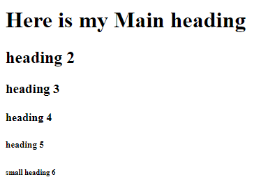

**Q 4) What is html paragraph?**

**What is the HTML tag for a paragraph?**

HTML <p> tag is use for representing paragraph. If you want to write a paragraph in your html document then paragraph tag is used.

**For Example-**

<!DOCTYPE html>

<html>

<head>

<title>Paragraph tag</title>

</head>

<body>

<p> This is an example of paragraph tag. If you want to write a paragraph in your html document then paragraph tag is used </p>

</body>

</html>

**Output –**

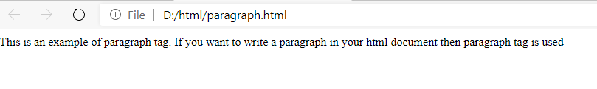

**1. What is horizontal rule in HTML?**

Horizontal rule in html is use in paragraph, if user wish to add some line spacing between the paragraph like shift spacing or thematic break then the concept of horizontal rule is used.

**2. What is horizontal rule tag in HTML?**

In HTML <hr> tag represents horizontal rule in your html document. <hr> tag use in between the paragraph tag for providing line spacing between the paragraph. <hr> tag does not have end tag.

**For example**

**<!DOCTYPE html>**

<html>

<head>

<title>hr tag</title>

</head>

<body>

<h1>My main heading</h1>

<p>

Horizontal rule in html is use in paragraph,

if user wish to add some line spacing between the paragraph

like shift spacing or thematic break then the concept of horizontal rule is used.

</p>

<hr>

<p>

In HTML <hr> tag represents horizontal rule in your html document.

<hr> tag use in between the paragraph tag for providing line spacing between the paragraph.

<hr> tag does not have end tag.

</p>

</body>

</html>

**Output-**

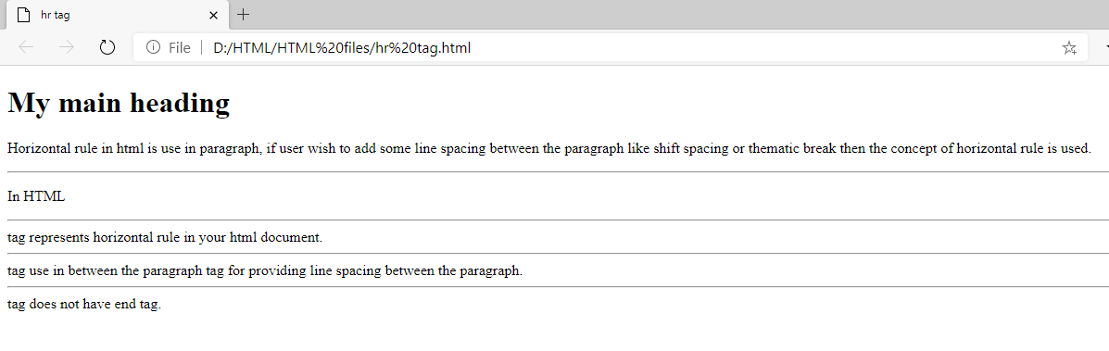

**Q 5) What is an html image? With example**

Html Image tag is use for Inserting an image into your html Page. Images are not diectly inserted into your html page but it is lincked with the web page. Image tag consist of src attribute which helps html content to specifies the url of the image. The src attribute is an important attribute in image tag. Src is a source where src specifies the location or path of the particular image where your image has been saved in your local computer.

< img src="D:\html\images\nature.png" width="700" height="500" >

For Example-

<html>

<head>

<title>Image tag</title>

</head>

<body>

< img src="D:\html\images\nature.png" width="700" height="500" >

</body>

</html>

**Output** –

